**SSH to your AWS Workstation**

**ssh devops@<public-ip-addr**> of your Workstation  
Password is : **Dev0p$!!/**

**Replace <your-name> with your name throughout the lab.**

**1. Run the below commands to create a pod object as <your-name>probe.yaml.**

|  |
| --- |
| $ mkdir /home/devops/probe  $ cd /home/devops/probe/  $ curl -f <https://pastebin.com/raw/wsFvgeSZ> > <your-name>-probe.yaml  $ vim <your-name>-probe.yaml |

Update <your-name> with your name as shown in the below screenshot.

Press **ECS :wq** and press **enter** to save and exit the vim editor.

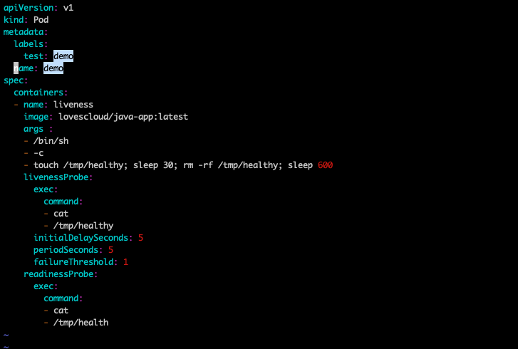

The command {**touch /tmp/healthy; sleep 30; rm -rf /tmp/healthy; sleep 600**} will create a directory named **healthy** in **tmp** directory and then deletes and hence the probes fail.

**2. Create a Pod**

|  |
| --- |
| $ kubectl -n <your-name> create -f <your-name>-probe.yaml |

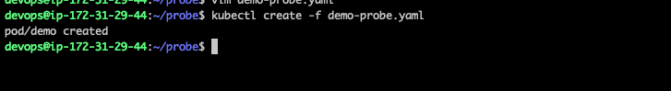

**3. Within 30 seconds, view the Pod events:**

|  |
| --- |
| $ kubectl get po <your-name> -n <your-name> |

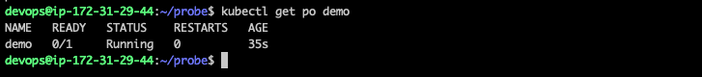

**4. Run the below command to describe the pod and check pod events.**

|  |
| --- |
| $ kubectl describe pod <your-name> -n <your-name> |

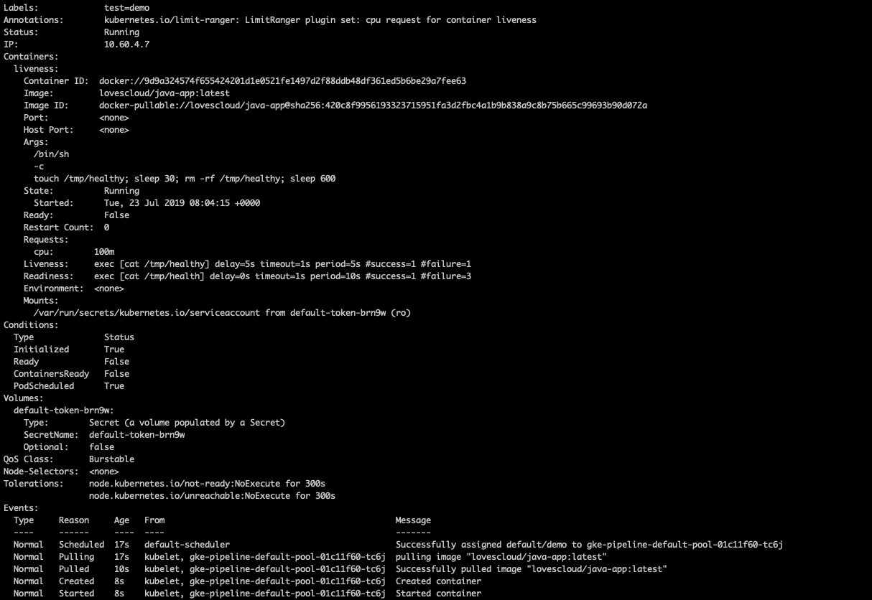

**5. After 30 seconds, view the Pod events again:**

|  |
| --- |
| $ kubectl describe pod <pod-name> -n <your-name> |

At the bottom of the output, there are messages indicating that the Liveness and Readiness probes have failed, and the containers have been killed and recreated.

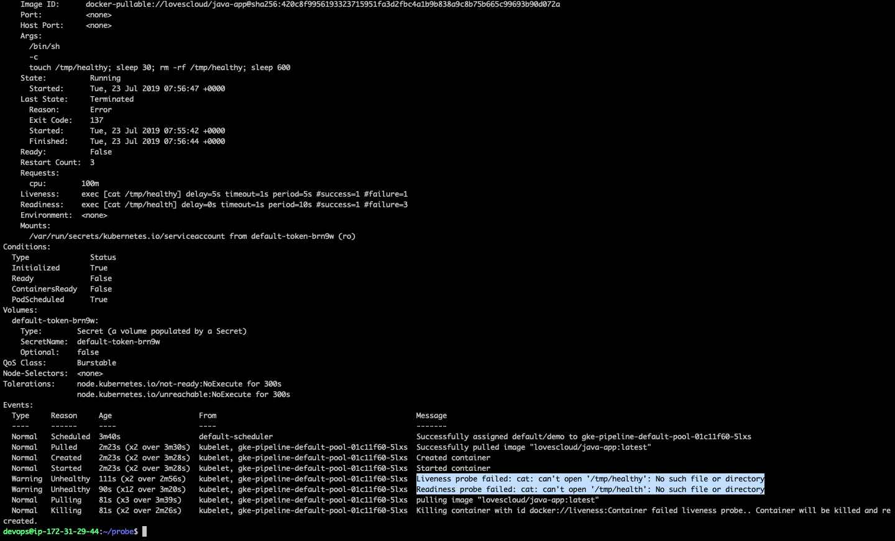

**6. Wait another 30 seconds, and verify that the Container has been restarted:**

|  |
| --- |
| $ kubectl get pod <pod-name> -n <your-name> |

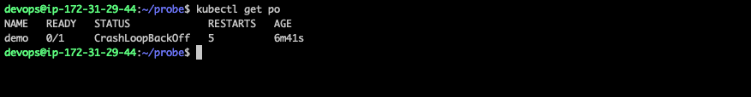

The output shows that RESTARTS have been incremented.

7. Clean up

|  |
| --- |
| $ kubectl delete pod <pod-name> -n <your-name> |